College of Arts & Sciences Accounting Services Meeting

Wednesday, June 13

10:30 a.m. – 11:30 a.m.

Toy Lounge, Dey Hall

Moving Expense Policy and Procedure Updates: Jim Klingler, Associate Dean, Finance and Budget Management
Significant changes to the university’s employee moving expense reimbursement policy and procedure are being implemented as a result of the 2017 Tax Cuts and Jobs act. Effective July 1, 2018 employee moving expense reimbursements will be processed via a lump sum payment ePar in ConnectCarolina, and the ePAR payment amount is the total amount of receipts increased by 30 percent to assist with the tax impact on the employee. The payment amount, including the 30 percent increase, cannot exceed the amount specified in the offer letter. The College reimbursement maximum, including the gross-up, will remain at $5,000. Additional information regarding these changes is forthcoming.
P-card System Changes:
A new online system delivered by our P-card partner Bank of America called “BofA Works,” will increase visibility and oversight for the P-card Program. This new system will improve accountability. What is great about P-cards is that they are a user friendly form of purchasing and are much cheaper to process than vouchers. The other great benefit is that campus also receives a rebate from BofA for spending. The bigger the transaction, the bigger the rebate.

- What will the new system do?
  - The holder or the holder’s reconciler can go into the system and see all transactions and reconcile
  - You will be able to split fund transactions
  - Transactions can be grouped for assigning financial information or documentation
    - Pilot groups have reported that this new system is very easy to use

- How will this better streamline transactions?
  - Approvers will have the ability to review and approve transactions.
  - The system is flexible enough to have multiple cards for one approver, or group assigned approvers to a card.
  - A significant business process change is having the ability to upload receipts
  - There will be significant reporting and dashboard functionality for approvers, managers, chairs, supervisors, and the Dean’s Office.

- Policy Changes under consideration:
  - Rentals
  - Athletic and Student Travel Expenses
  - Business Related Membership Dues
  - All Conference Registration Fees

- Timeline:
  - July 6th - Verify Card holders, assign reconcilers, approvers.
  - August 1st - Webinar available to help with the new process and any questions that may arise
  - August 16th –P-card Redeployment

Finance Announcements: Jim Klingler, Associate Dean, Finance and Budget Management
- OSR Remediation
  - Still actively negotiating with the Provost’s Office.
  - There will be more updates to follow.

- Budget Model Update
  - This item is now active
  - Meetings will start soon to create a plan
  - New budget model to be created in the next 3-6 months

- SVP Business Operations – New Director for Carolina Service will change the backbone of business at UNC.
Summer Salary Breakout Sessions: Sabrina Flowers and Kristen Rogister, CAS Budget Analysts
- What is summer salary and who is eligible?
  - Only Nine-month faculty are eligible for summer salary and are limited to one third of their nine-month base salary (excluding administrative supplements) for Summer School or other summer salary.
  - Summer salary is payment for work completed during summer months (begins the day after Spring Commencement and ends the day before fall semester classes begin).
- How does the faculty member receive summer salary?
  - Process a lump sum payment for the faculty member in Connect Carolina in the HR Work Center
  - Choose summer salary reason code
  - Effective date must be the first of the month the payment is to take place in, which is also the month the work will be completed in : Ex. Work Period Start Date: 6/14/2018, Work Period End Date: 7/5/2018, Effective date: 7/1/2018
  - Add comments: # of days worked, daily rate, explanation of work
  - Use the net salary calculator when using non-state funds
  - Submit the ePar by the 10th of the month to ensure timely approval

- How do I calculate summer salary?
  - Fill in the yellow fields on the summer salary calculator (Link provided below).

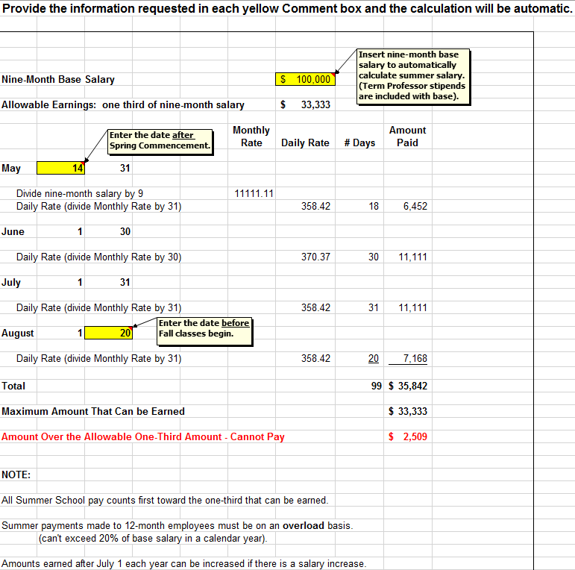

The Daily Rate and total amount allowed for each month will populate in “Amount Paid Column.”
Important Note: Amount cannot exceed “Maximum Amount That Can be Earned.”

- Summer Salary Calculator Form: https://collegeintranet.web.unc.edu/deans-office-business-center-and-university-forms/

